https://smartshala-erp.vercel.app/


Hide that section as of now or remove it

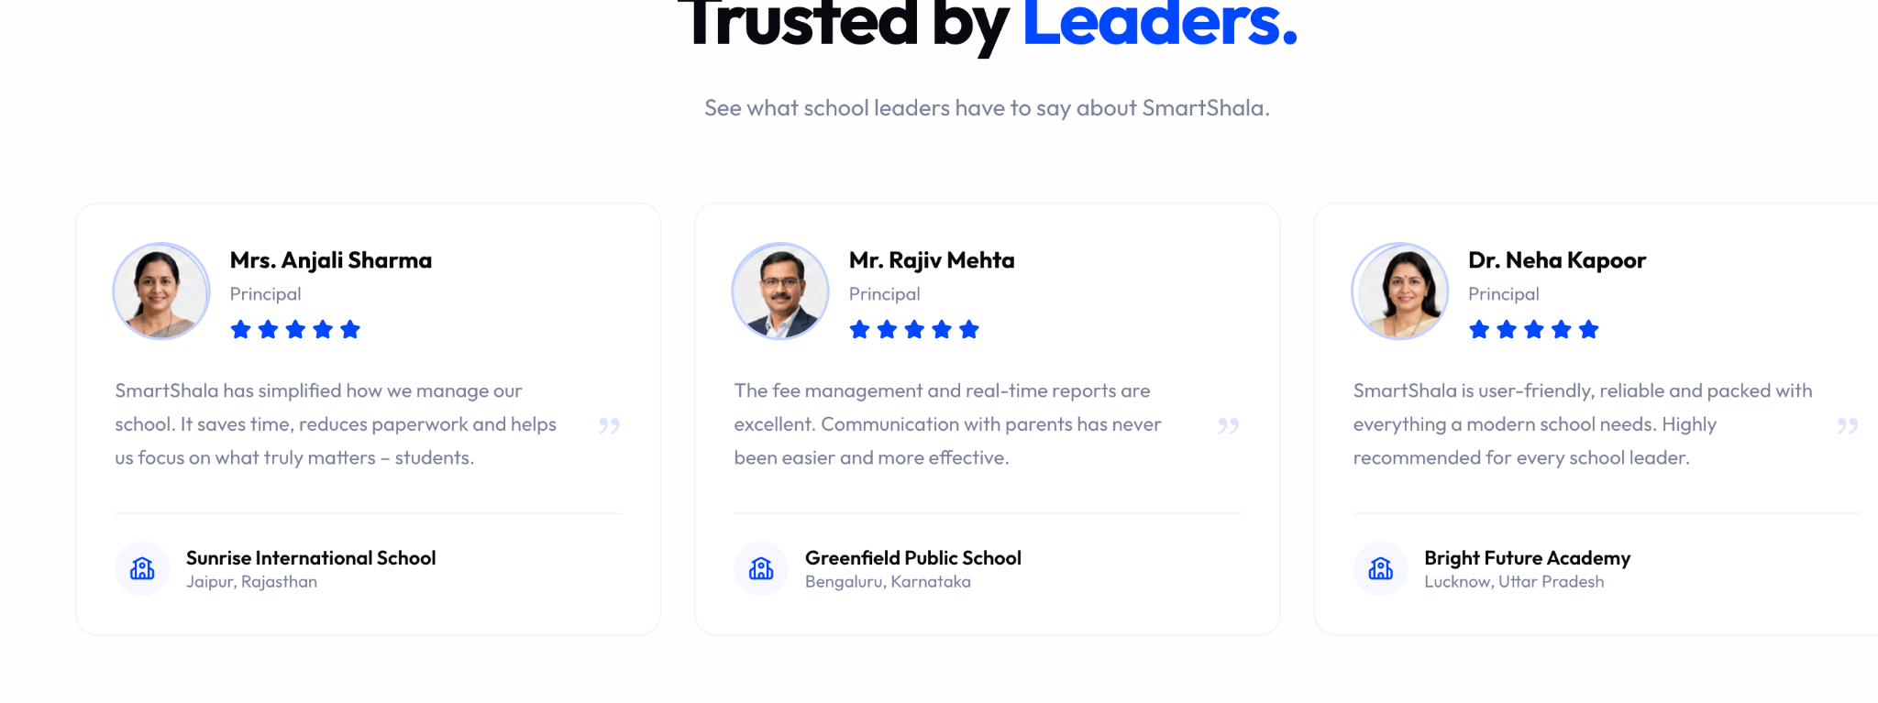

Remove school name from reviews

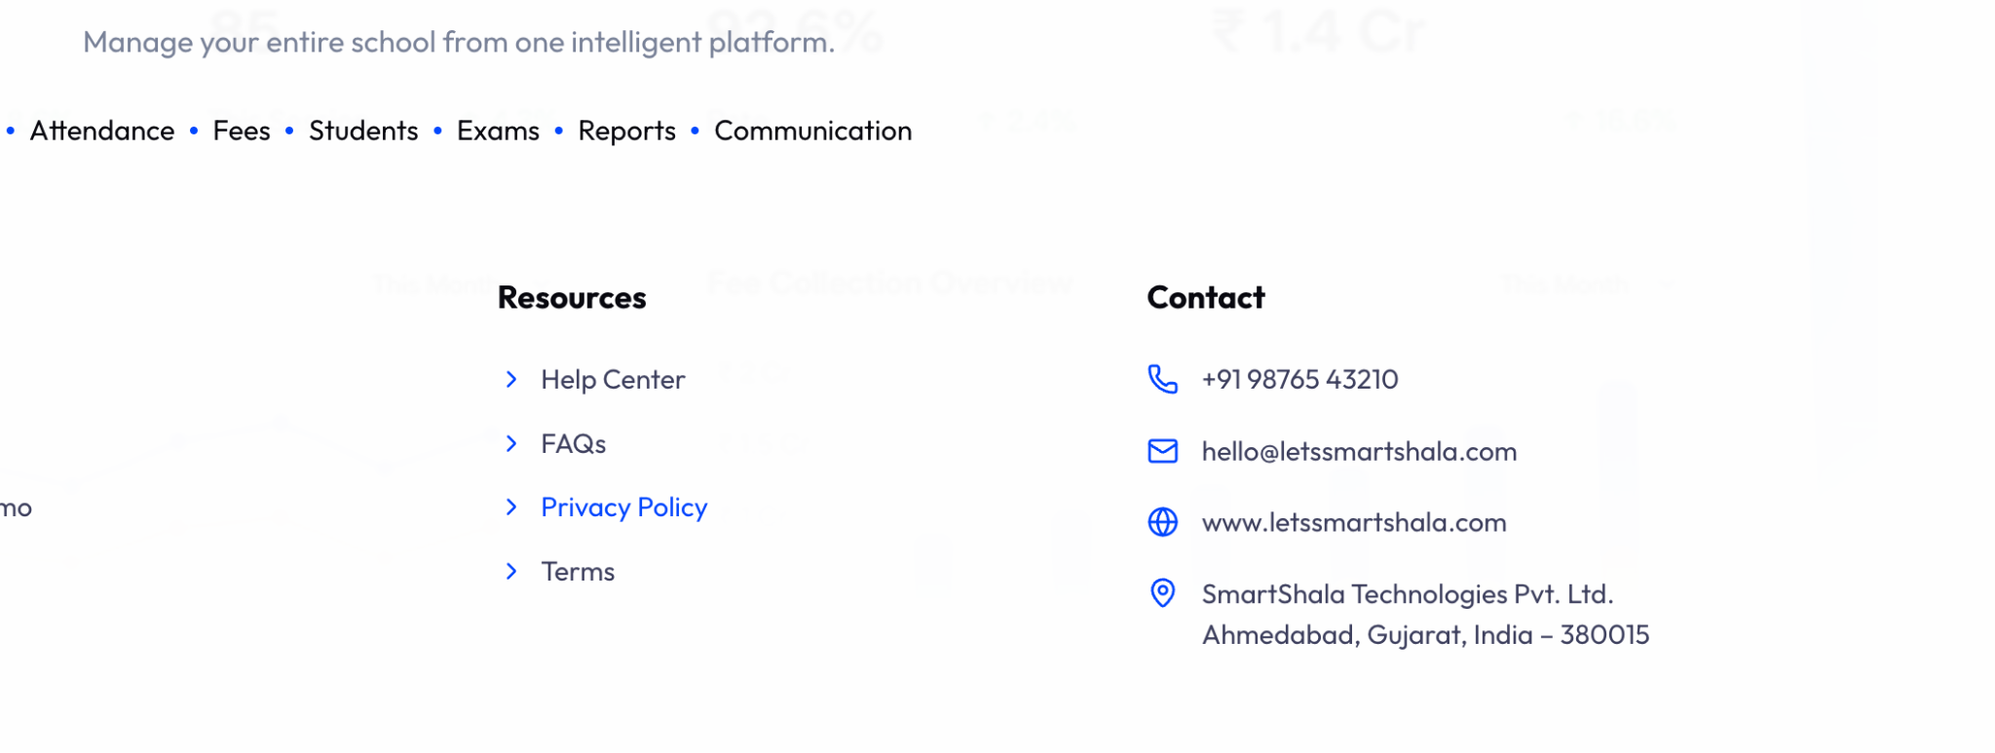

Update contact info as per below

support@letssmartshala.com
www.let’ssmartshala.com

Company name - Hybrid Monks LLP
Ahmedabad, Gujarat, India – 380015
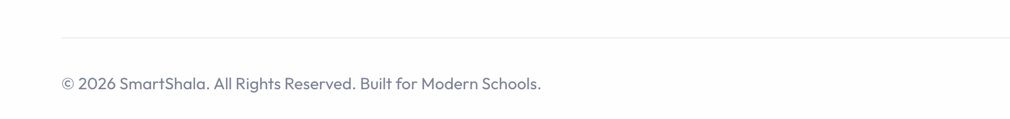
@2026 Smart Shala (Product by Hybrid Monks LLP), All Rights Reserved
Remove pricing page
Remove login page
In resources add blog page
Just keep feature page remove modules page both seems same I think
https://smartshala-erp.vercel.app/about
Ask content for this one from Mehul
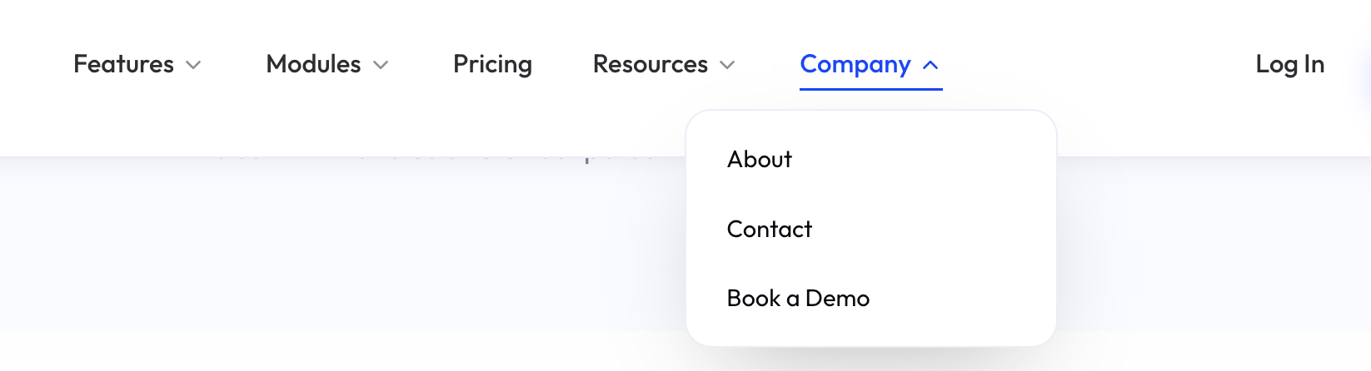

Remove drop down and keep company
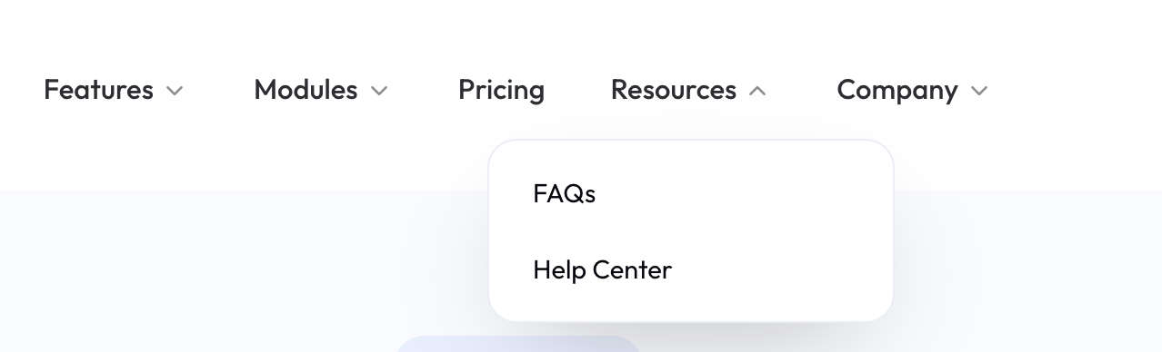

Remove help center for now

